AWS Task-4

Linux EC2 instance with a web server.

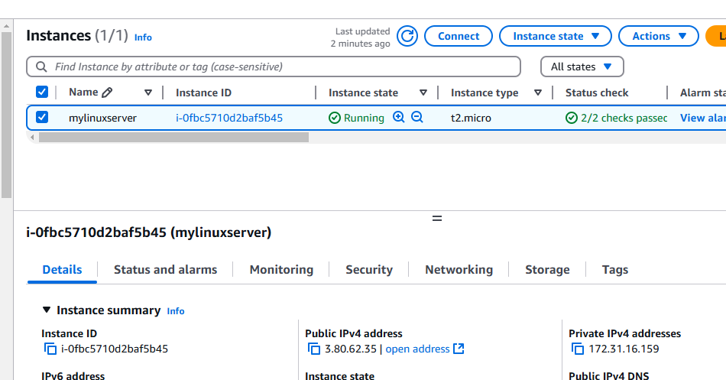

Launched windows EC2 instance with webserver.

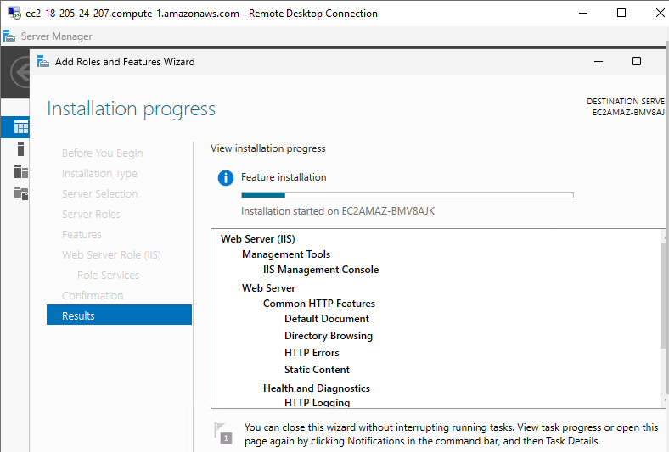

Snapshot creation after 5GB volume attached to the instance

